Ideation Phase
Brainstorm & Idea Prioritization

Date | 29 September 2026
Team ID | SWTID-2026-9956
Project Name | Auto Ticket Classification Using Flow Designer
Maximum Marks | 4 Marks

Auto Ticket Classification Idea Prioritization:
Step 1: Team Gathering, Collaboration & Problem Statement
Selected Problem Statement
The school IT helpdesk receives multiple incident requests daily from students and teachers, such as Wi-Fi issues, projector failures, password problems, and slow computers. Currently, IT staff manually review and categorize each request, making the process time-consuming and inefficient.
Customer / User
IT Helpdesk Staff

Key Problem
Manual incident classification and categorization causes increased workload, delays, and inefficient ticket management.

Step 2: Brainstorm, Idea Listing & Grouping
Idea | Description | Group
Automatic Ticket Classification | Automatically identify the type of incident from the ticket description. | Automation
Keyword-Based Analysis | Analyze keywords from the Short Description and Description fields. | Classification
Automatic Category Assignment | Assign the appropriate category based on identified keywords. | Automation
Automatic Subcategory Assignment | Select the relevant subcategory based on the assigned category. | Classification
Flow Designer Automation | Use ServiceNow Flow Designer to automate the complete classification workflow. | Workflow
Structured Ticket Information | Maintain consistent and standardized incident information. | Data Management
Automated Notification | Notify the caller when the incident ticket is created. | Communication

Example Classification Logic
Wi-Fi / Internet keywords → Network
Projector / Display keywords → Hardware
Password / Login keywords → Account / Access
Slow / Performance keywords → Performance

Step 3: Idea Prioritization
Idea | Priority | Reason
Automatic Ticket Classification | High | Directly addresses the main problem of manual classification.
Keyword-Based Analysis | High | Enables the system to identify the issue from ticket descriptions.
Automatic Category/Subcategory Assignment | High | Reduces manual effort and improves consistency.
Flow Designer Automation | High | Connects the classification steps into an automated workflow.
Structured Ticket Information | Medium | Helps maintain consistent and manageable incident records.
Automated Notification | Medium | Improves communication with the caller after ticket creation.

Final Selected Idea:
ServiceNow Flow Designer–based Automated Incident Classification
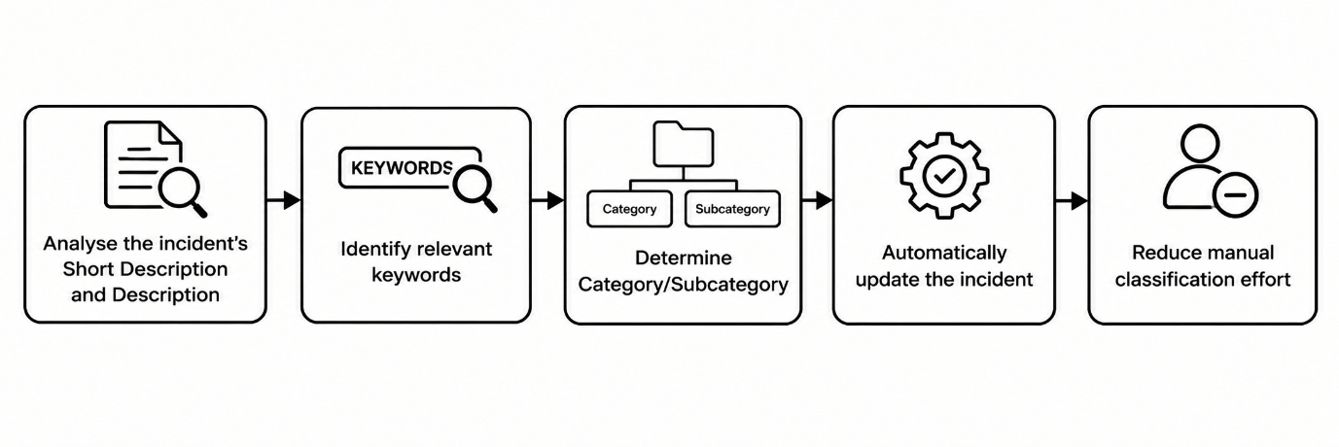
This follows the template's intended progression from
problem selection → idea generation and grouping → idea prioritization.

